

INDIVIDUAL ASSIGNMENT

COMP40004

**WEB DEVELOPMENT AND OPERATING SYSTEMS-1**

**CFK23A1COM**

HAND OUT DATE: 3nd week

HAND IN DATE: ASSIGNMENT2: 19th Jan 2024

WEIGHTAGE: ASSIGNMENT 2: 30%

**INSTRUCTION TO CANDIDATES:**

1. **Students are advised to underpin their answers with the use of references (cited using the Harvard Name System of Referencing).**
2. **Late submission will be awarded zero (0) unless Extenuating Circumstances (EC) are upheld.**
3. **Cases of plagiarism will be penalized**
4. **Assignment presentation should be submitted in the form of softcopy and hardcopy both; modeling work should be submitted in softcopy form**



“ This project is about creating a wildlife website to showcase Sri Lankan's rich wildlife.

I come up with the idea that Travel Lanka(Pvt)Ltd. Is a privet company. They help

Foreigners to get a quality tour inside Sri Lanka. They have hired vehicles, tourist guides,

Hotels and created a wildlife website for tourists to get a good idea about Srilankan wild

Life. By using this wildlife website tourists can get a good idea about what they are going

To look inside Sri Lanka. For example they can get a basic knowledge about srilankan

National parks, wild cats, birds, marine life, and proper knowledge about Wilpattu and

Yala national parks ”

**Introduction & Guide**

As an index page, I created the Travel Lanka official page. It contains the other branch

Websites (ex: wildlife website, tourism guide website, hiring vehicles website, ….).

There’s a Button called Discover More, If you click it they bring you to a website where you can learn more information . In wildlife Website you can see a lot of information about Srilankan animals, amazing facts about Srilanka, wildlife highlights, and every national park. By using the navigation bar you can navigate through the website.

**What I learned**

1. **Wireframes**

Before I came to the university I didn’t know about wireframes. With the help from Mr. Pradeep Pallegama, I discovered a software called Figma, where we can create wireframes. By using Figma now, I can even create animation too.

1. **Html**

I did information & com. Technology for my A/Ls, there for I have a basic knowledge about HTML, CSS, PHP & My sql, but to create a good website that knowledge is not enough. Here are few tags I learned,

* <i> - to add icons
* <iframe> - to add google map
* <section> - to replace <div>
* <script> - to add JS
* Class
* <footer>
* <button>
* <nav>

1. **CSS**

Here are few CSS line that I learned from creating this project,

* @import url(“”)
* Line-height
* Background : transparent
* Webkit-scrollbar (to change default scrollbar)
* Position:fixed
* Overflow:scroll
* List-style
* @keyframe {to add animation}
* Filter
* Transition : translateX (move in x axis)

1. **GitHub**

Learning about github is one of the best thing as a computer science student.

I learned how to push our project to github, remotes, live hosting, what is a repository and how control github using vscode.

1. **VScode**

I learned new extensions :

* Live server
* VS code icons / new themes

1. **Web manifest**
2. **Responsive Web application**
3. **Tailwind CSS**

**Challenges I Faced**

1. **Responsiveness**

This is the most annoying challenge that I faced. But responsiveness is the most valuable thing in a website because most of the time everyone in this world access internet using mobile phones. There for responsiveness is a big part of our websites.

1. **Web Manifest & Web Application**

I tried so many times to add the manifest.json file and configure it but it didn’t worked well. My favicons are worked perfectly but there were no install button showing on the website.

1. **GitHub Live hosting**

I created a new repository and upload all files that I have. But when I go to pages and click live host link, my website didn’t showed at the first time.

1. **Finding Quality Images**

There are lot of images in our website. It should be in good quality. Finding good

Free images was little bit of a challenge.

1. **CSS**

CSS is a little bit hard language, But that is a very good language to master. Creating a good CSS code is a hard process because we put classes/ ids in our every HTML tag to identify it. There for CSS code should be perfectly organized.

1. **Responsive Image Gallery**

This was a bit of a challenge for me because it required advanced CSS skills.

1. **How to Use Good Colors**

I decided to create my website without any background colors. Then it can be different from others websites.

This challenges gave me a good idea and taught me how hard it is to be a good web developer. With helps from Mr. Pradeep pallegama and using lot of websites, lot of youtube channels I managed to overcome this challenges.

**How I Overcame My Challenges**

1. **Responsiveness**

With help from Mr.pradeep pallegama I get to know about media queries.It helps me to create a good responsive web site. And with some youtube channels that I watched I finally understand how the media queries works.

@media screen and (max-width:600px) { }

***Youtube channels that I watched***

* [Kevin Powell](https://www.youtube.com/@KevinPowell)
* [Codehal](https://www.youtube.com/@codehal)
* [SuperSimpleDev](https://www.youtube.com/@SuperSimpleDev)
* [freeCodeCamp.org](https://www.youtube.com/@freecodecamp)

1. **Web Manifest & Web Application**

This is the first time I’m creating a website, so I never heard about web manifest, progressive web applications. First time my fav icons worked perfectly but the browser did not showed the install button, That means my manifest.jason file had a problem. With help from my friend Sandeep I found a new website called [Progressier](https://progressier.com/pwa-manifest-generator). I created and edit my manifest file again. Now my manifest thing is working perfectly.

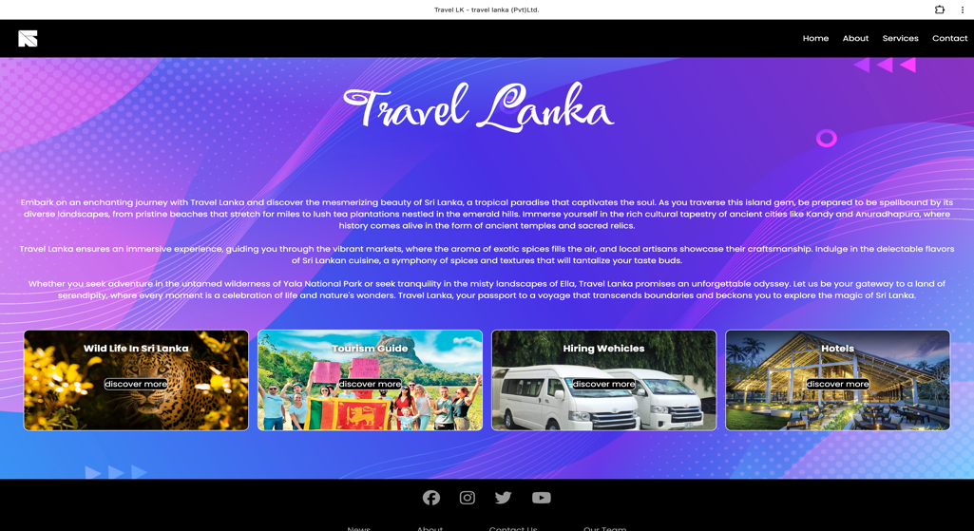

1. **GitHub Live Hosting**

After watching few youtube videos I manage to create a github account, good repository, and I learned how live host is working. Actually learning github is so good its so useful because we can edit code in vscode and push right away to the github quick. While creating this website source control is the most valuable thing I learned.

1. **Founding Quality Images**

After so many searches I found a websites with so many free quality images.

* [Unsplash](https://unsplash.com/s/photos/free-images)
* [Freeimages](https://www.freeimages.com/)

1. **CSS**

Creating a good source code is hard but it didn’t depend on how many videos you watched, It depend on how many time you practice the code. So its all about my practice.

1. **Responsive Image Gallery**

After watching a one video I managed to create a image gallery.

* [CodingMasterYt](https://www.youtube.com/@CodingMasterYt)

1. **How to Use Good Colors**

Because I have been using Pinterest for a long time, I know little bit about colors.

We have to create a wild life website there for I used green color plate as my colors.

